Calculating Square Root by Long Division Method

Long division is a method for dividing large numbers into steps or parts, breaking the division problem into a sequence of easier steps. We can find the exact square root of any given number using this method. Let us understand the process of finding square root by the [long division](https://www.cuemath.com/numbers/long-division/) method with an example. Let us find the square root of 180.

* Step 1: Place a bar over every pair of digits of the number starting from the units' place (right-most side). We will have two pairs, i.e., 1 and 80
* Step 2: We divide the left-most number by the largest number whose square is [less than or equal to](https://www.cuemath.com/numbers/less-than-or-equal-to/) the number in the left-most pair.

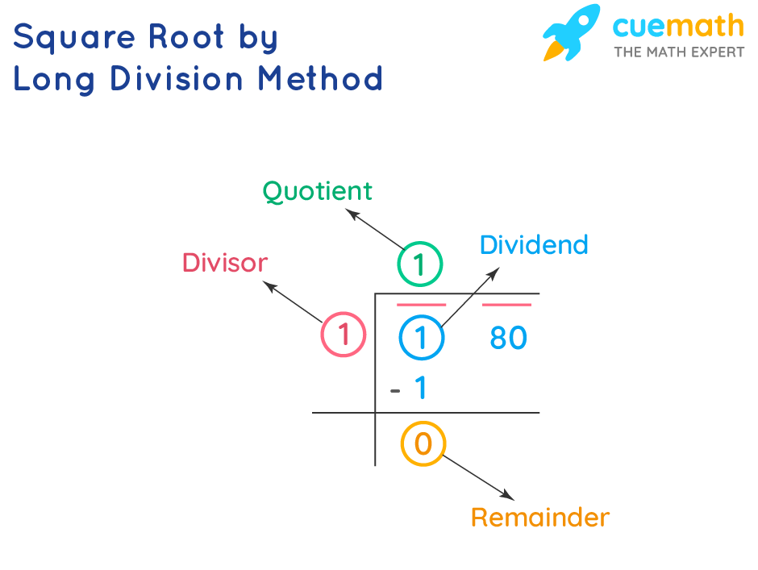

Step 3: Bring down the number under the next bar to the right of the [remainder](https://www.cuemath.com/numbers/remainder/). Add the last digit of the [quotient](https://www.cuemath.com/numbers/quotient/) to the [divisor](https://www.cuemath.com/numbers/divisor/). To the right of the obtained sum, find a suitable number which, together with the result of the sum, forms a new divisor for the new dividend that is carried down.

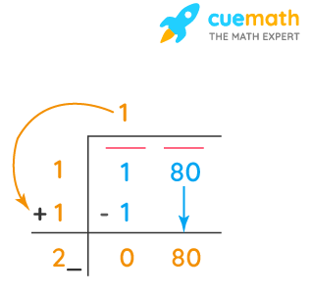

Step 4: The new number in the quotient will have the same number as selected in the divisor. The condition is the same — as being either less than or equal to the dividend.

Step 5: Now, we will continue this process further using a decimal point and adding zeros in pairs to the remainder.

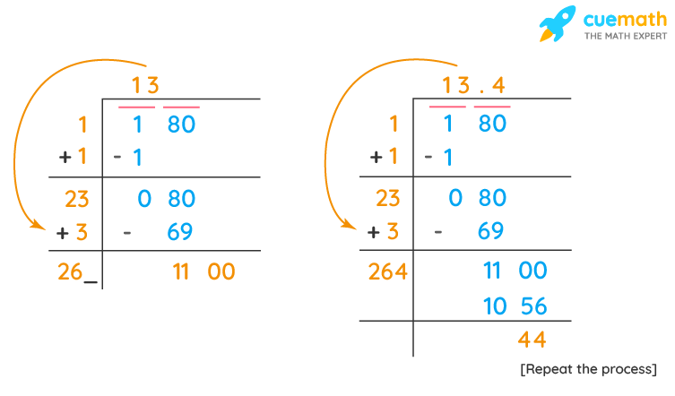

Step 6: The quotient thus obtained will be the square root of the number. Here, the [square root of 180](https://www.cuemath.com/algebra/square-root-of-180/) is approximately equal to 13.4 and more digits after the decimal point can be obtained by repeating the same process as follows.

